Robokey: Automated Form Filling



**Lecturer:**

**Jude Joseph Lamug Martinez**

**Arranged by:**

**2702357996 - Edbert Tan**

**Robokey**

**Computer Science Faculty**

**Binus International University**

**Project Specification**

Robokey is made to automatically fill web forms for taxes or overtime activities. It is made primarily using the robot feature. It will take a csv file and put its contents into a web form when the program is run.

**Solution Design:**

**-Class Diagram**

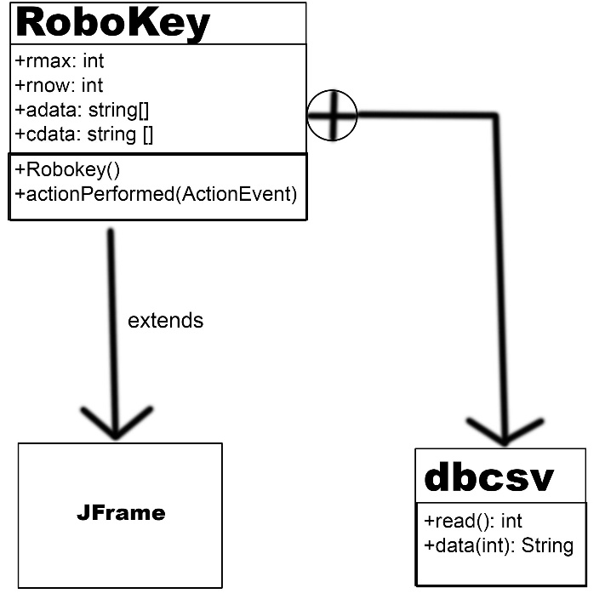

**-What Was Implemented**

The robokey uses the following Java features:

-BufferedReader: used to get data from the csv/Excel file

-arraylist: puts the data from the BufferedReader into an arraylist

-array: puts the data of the arraylist into an array

-JFrame: used to display the java program in GUI form

-MouseListener: used to get the coordinates of the initial mouse click of the Robokey when the JFrame is extended

-ActionListener: used to load commands, load name of chosen data, save commands list to a txt file, change which data is being entered, and run RoboKey when pressing their respective buttons

-switch: used to determine which action the robot should do based on which part of the command list the robot is at

-robot: used to automate the process of filling the web form by using virtual keyboard to do actions

**Screenshots**

Before running program

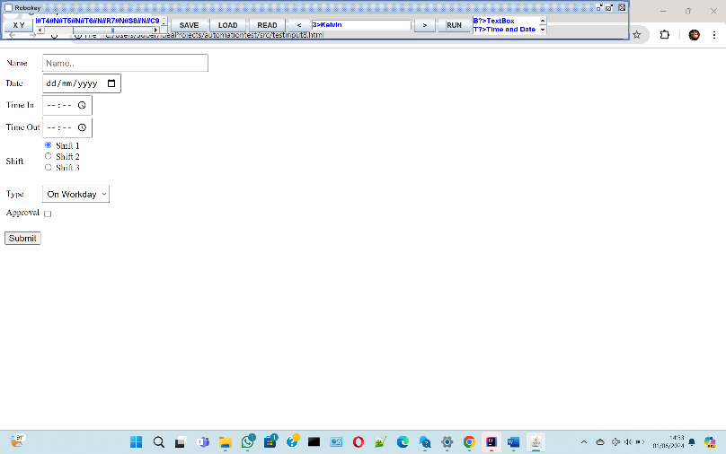

After running program

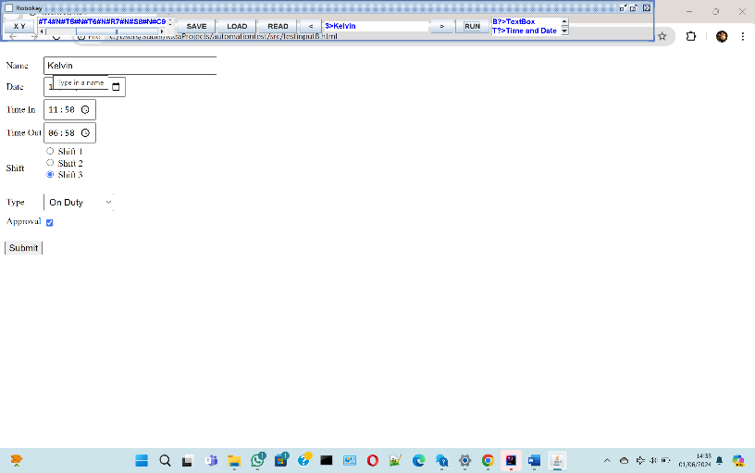

**Video Demo**

<https://drive.google.com/file/d/1kI6a5fLKUZtNeqUQGY0bkrDDi0AFJw2R/view?usp=sharing>

*there is a slight error, the program typed “Paty” instead of “Patty” but it was fixed after the video